SALES ASSIGNMENT

What exactly I have done?

Collected sales data of a store for the year 2011, 2012 & 2013 for the products that are sold in the store.

There are total 5 categories of product (i.e. food, beverage, gambling, Leisure, Drug, Hygiene) which essentially

Stakeholders/Audience for the project:

* Store manager.
* Suppliers
* Sales team
* Manufacturers
* Suppliers
* Investors

Why this data was collected in first place?

This data was collected at first place to understand the sales pattern, to understand which products are preferred by customers, pattern of food consumption, future demand of product, inventory, focus on supply chain (production and demand), to help businesses set out strategy.

Questions that I am trying to answer from this data

1. What was the overall sales pattern in three years i.e. 2011, 2012, 2013.
2. Which category of product was sold most?

|  |  |  |  |
| --- | --- | --- | --- |
| **Product category** | **Sum of Total 2012 Sales** | **Sum of Total 2013 Sales** | **Sum of Total 2011 Sales** |
| Food | 1168570 | 1191312 | 1156997 |
| Beverage | 277831 | 282984 | 275075 |
| Gambling | 80269 | 81808 | 79477 |
| Leisure | 17912 | 18284 | 17735 |
| Drug | 16781 | 17081 | 16616 |
| Hygiene | 598 | 613 | 591 |
| **Grand Total** | **1561961** | **1592082** | **1546491** |

Q. Product sold most in the store

Q. Sales of $1 lottery ticket across months in a year

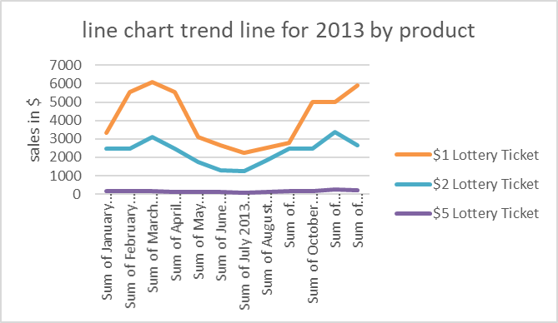

SALES PATTERN OF FOOD PRODUCTS:

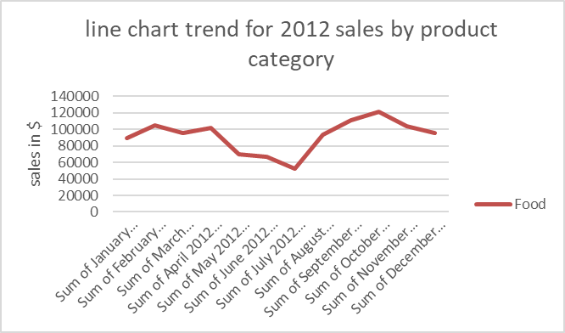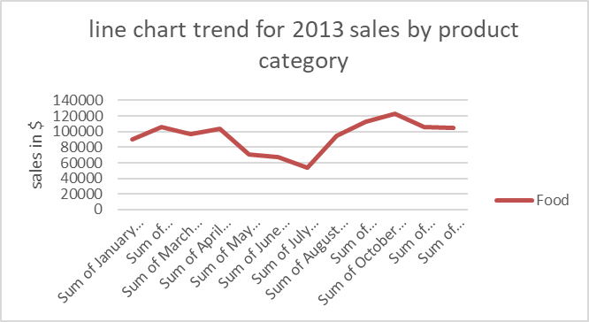

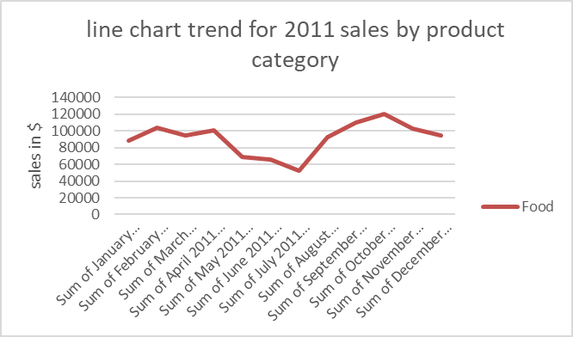

SALES PATTERN OF BEVERAGES:

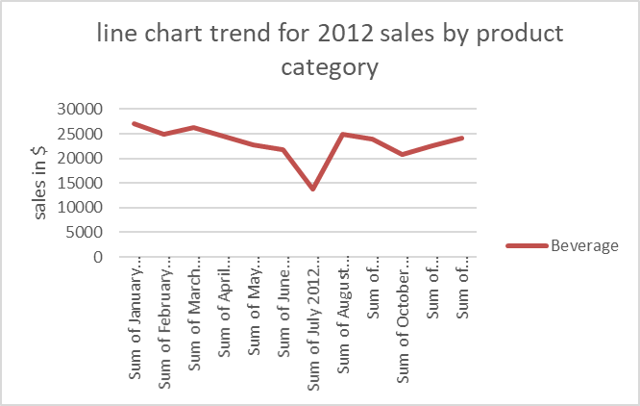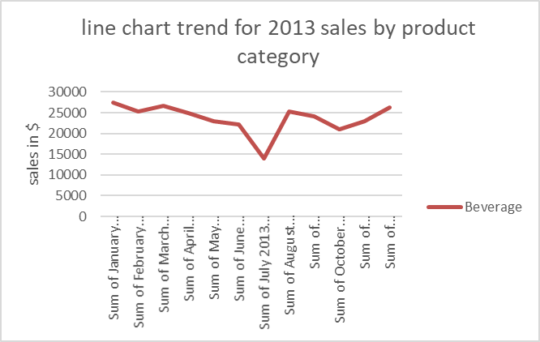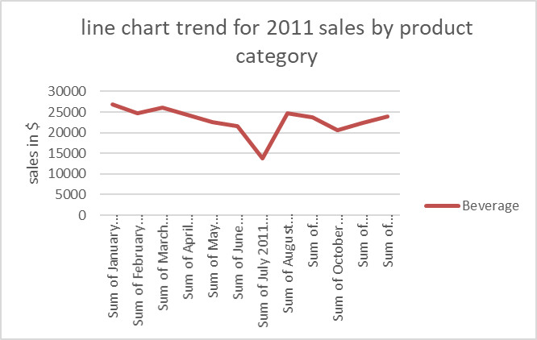

INFERENCES:

The sales at store decreases rapidly in the month of June and recovers by the end of month of july.

The store should give out more offers, discounts or opt for other strategies to attract more customers in this period.

The store has good food products sales in the month of September and October. they should maintain a good stock of these products in these months to boost their revenue further.

The store has good $1 lottery ticket sales in the range of February to April and October to December, so should maintain good stock of it in these months.

The store has good sales of beverages from November to march and keeping a good stock of it will add to their revenue.